Inventory Management
Facilities Information Management Administration (FIMA) system has numerous panels required for inventory processing and control. The below listed titles are the Inventory Management Panels. This document explains the following FIMA steps necessary to accomplish these processes:
- Item Maintenance (pg 2)
- Item Location (pg 8)
- Vender Maint (pg 10)
- Vendor/Item
- Manufacturer Maint
- Manufacturer/Item
- Cycle Count Process
- Physical Count
- Cycle Count Override
- Qty On Hand Info
- Create Label File
- Inv Trans Rpt
To perform these tasks, you will be using the mouse to select and open applications and folders and to make selections within applications. The following terms for using the mouse are used throughout these instructions:
When you see this… | Do the following…
Click | Click the left mouse button once. This will select an application icon or a folder.
Right-Click | Click the right mouse button once. This will open a menu of options for a selected application icon or folder.
Double-Click | Click twice rapidly with the left mouse button. This will open a folder or start an application.
Scroll | Roll the scroll wheel forward or backwards depending on the direction required on the document. Forward = UP, Backwards = DOWN
(See Explanation of Terms for all descriptions of information entered)
Item Maintenance
After opening FIMA, click on the Inventory Management button. The following set of tabs will appear:
Click on Item Maintenance. This screen appears.
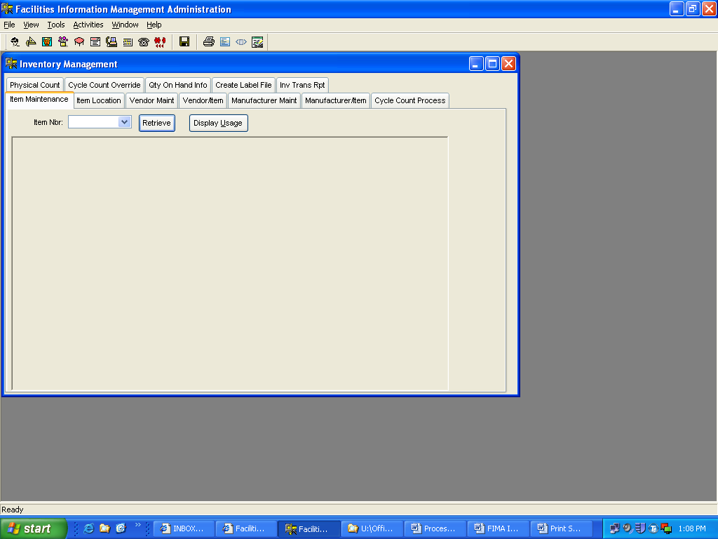
This screen is used for looking up information about or adding new items to inventory.
To review information about items already in inventory, either enter the item number if known or click on the Drop Down Arrow A list of all items, active & inactive, in FIMA will appear.
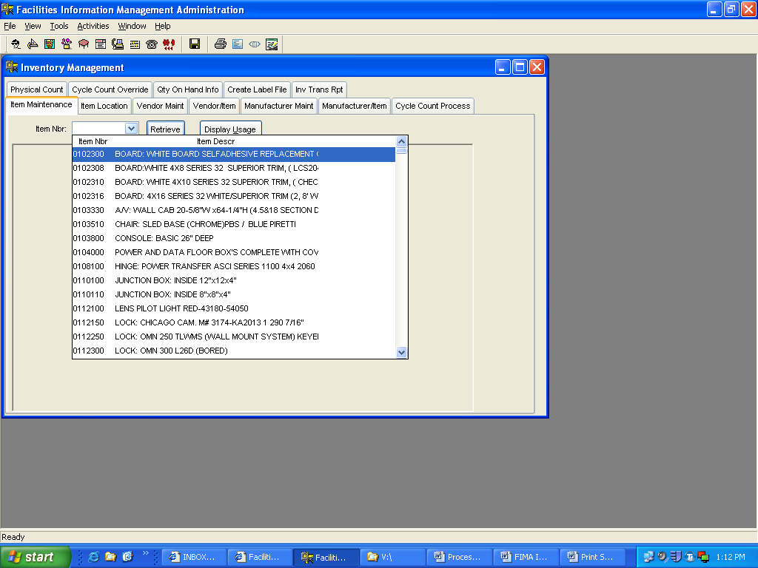
To select an item either scroll down or click and hold, the blue bar under the Up Arrow, and drag down to the required item number. Next, click on required item number. Next, click on the Retrieve Button . The information for the selected item is now on the screen.
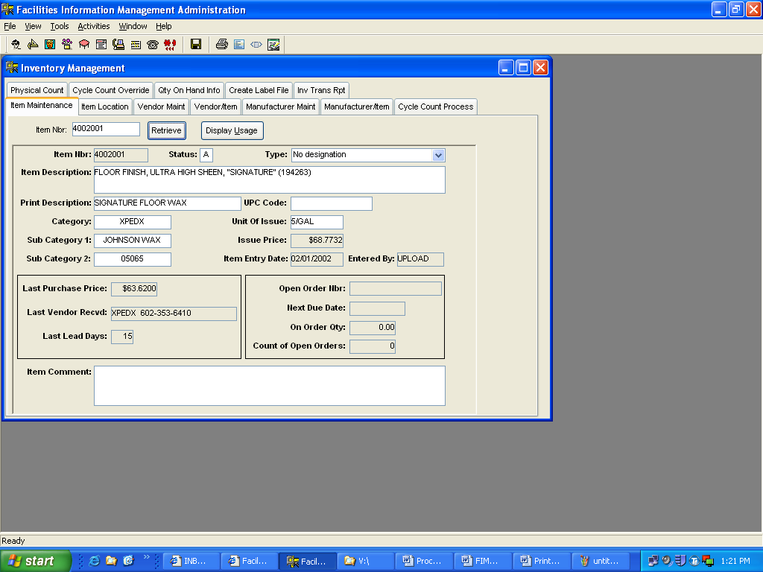
This screen is where changes can be made to inventory items.
The blocks that are white are the only fields that can be changed on this screen. Below is a list of what is required in each field:
Status “A” = Active
“I” = Inactive
Type No Designation
“D” = Dead Stock
“E” = Emergency Stock
“P” = Temporary – Classroom Project
Item Description Self Explanatory, the vendor’s part number is entered after the description, in parentheses. Use the same formats.
Print Description Self Explanatory, shorter version of above description
Category Vendor’s Name
Category 1 Manufacture’s Name
Category 2 Manufacture’s Part Number
UPC Code Not used at this time
Unit of Issue Self Explanatory, i.e. EA, BOX, etc.
Item Comment This block can be used for any and all comments regarding this item. i.e. Can only purchase from. Must order in qty’s of 100, etc…
All Other Blocks The remaining grayed out blocks contain other useful information.
Issue Price Current Issue Price
Item Entry Date Self Explanatory
Entered By Name of individual that loaded new item
Last Purchase Price Self Explanatory
Last Vendor Recvd Self Explanatory
Last Lead Days Number of days the item took before delivery
Open Order Nbr Material request number and Blanket or P-Card
Next Due Date Expected Delivery Date
On Order Qty Self Explanatory
Count of Open Orders Number of orders open for this item
This panel can be used to check the usage of items in inventory also. To accomplish this click on the Display Usage button. The following panel appears.
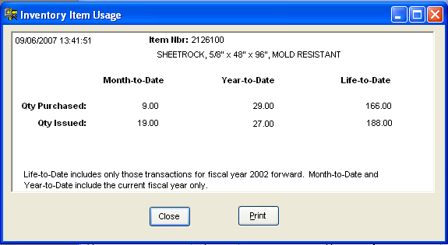
There are three columns of information and two rows of information for inventory count and utilization purposes.
This panel is also used for adding new items to inventory. This is only accomplished by the Supervisors. Before adding any items to inventory, an item number needs to be selected, a warehouse location must be assigned and at least three price quotes must be received. Upon receiving the three (3) price quotes, select the vendor who provides the lowest price. Then assign an item number. Review the description of the item and select an item number that closely resembles the new item description. Next a warehouse location has to be selected. Review the item to be added and try to determine where in the warehouse the item should be located. Look at the size, maximum quantity stocked and which shop has requested the addition. Next, select an open location closest to like items for that shop. The item can now be entered into FIMA. Complete the following steps to add this item to FIMA.

Right Click anywhere inside the large box below the Item Nbr block. Select “Add”
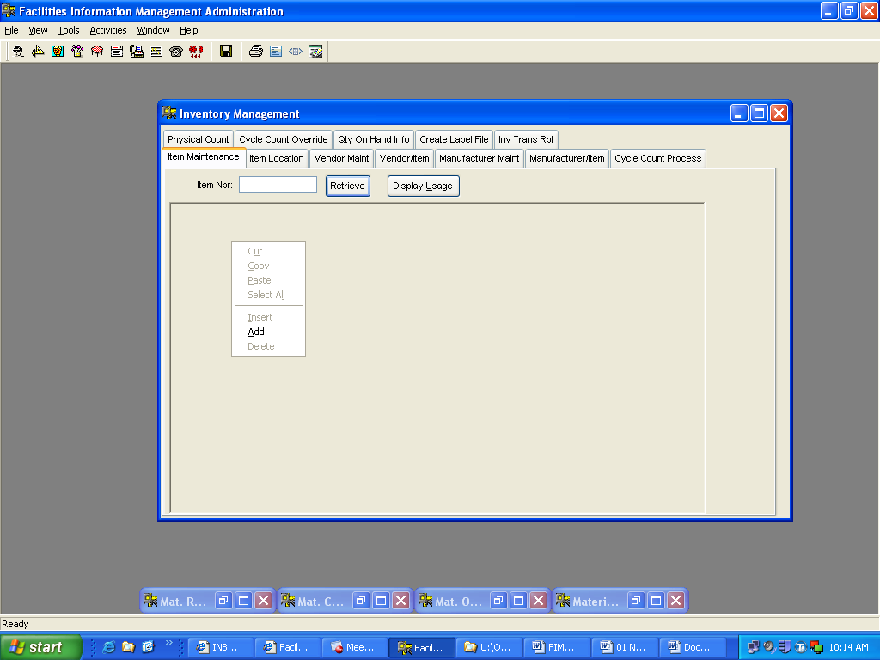
The new item add screen appears.
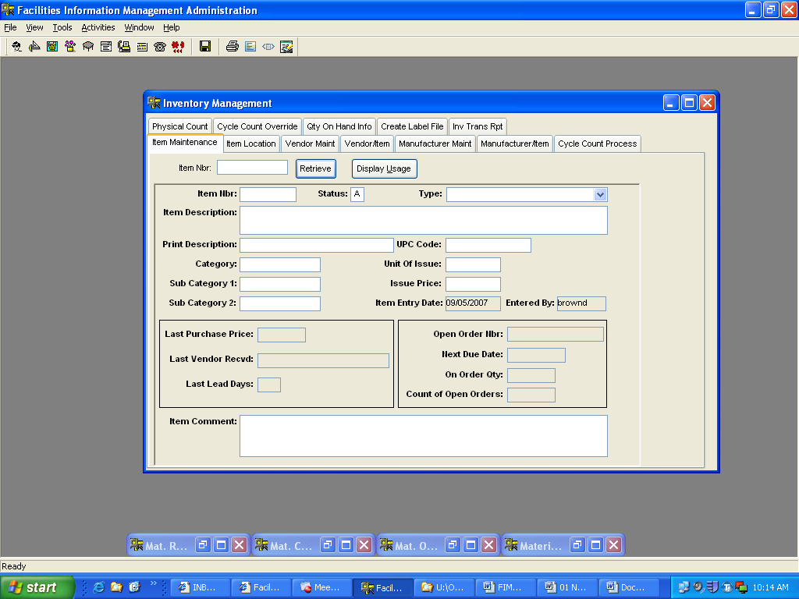
All the information for the new item is entered on this screen.
The blocks that are white are the only fields that information can be entered into. Use the tab key to move through each field. Below is a list of what is required in each field:
Item Nbr Enter the new item number
Status This field is automatic when adding new items
Type Leave this field blank for new items
Item Description Enter a complete description for the new item, enter as much information to describe the item. Enter the vendor’s part number, after the description, in parentheses.
Print Description Enter a shorter version of above description
Category Enter the Vendor’s Name
Category 1 Enter the Manufacture’s Name
Category 2 Enter the Manufacture’s Part Number
UPC Code Not used at this time
Unit of Issue Self Explanatory, i.e. EA, BOX, etc.
Issue Price Enter the price from the lowest vendor price quote
Item Comment This block can be used for any and all comments regarding this item. i.e. Can only purchase from. Must order in qty’s of 100, etc…
After all information is entered click on the Item Location tab.
The below box appears, select yes if all information was entered correctly.
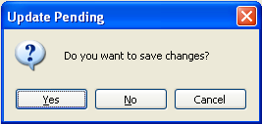
After selecting one of the above buttons, the Item Location panel appears and information can now be entered here.

Item Location
On this panel the warehouse number, min and max qty’s, location, cycle count code and the next count date are entered for new items. Information can also be viewed or certain blocks can be changed/updated. Use the “Tab” key to move to each block.
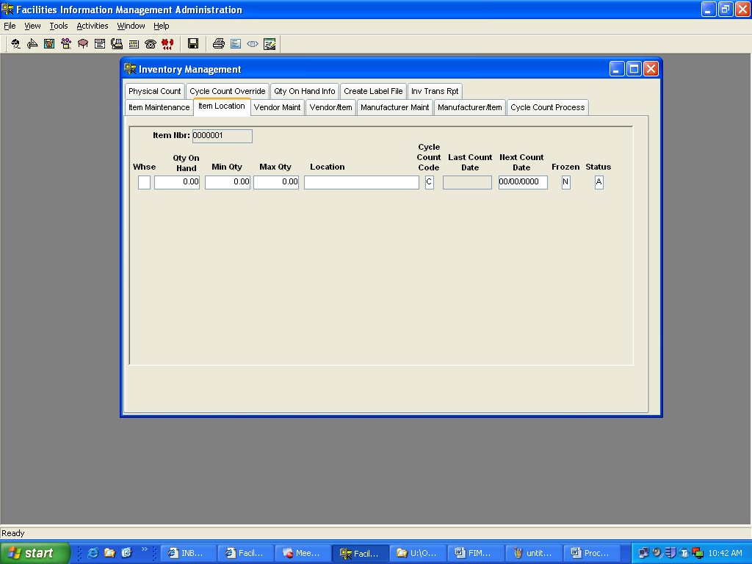
The first block is Whse; enter the warehouse number for this item. Warehouse number 1, is for all Material Control items. The warehouse number can not be changed once the information is saved. There are other warehouse numbers in FIMA; these numbers are for out lying warehouses. I.E. 2 for the Lock Shop, 21 for the Carpenter Shop, etc.
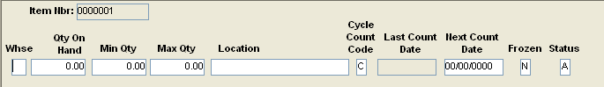
The next block is Qty On Hand; leave is this block at 0.00 for new items. This block will contain the on hand quantities for items already loaded.
Next is the Min Qty block; enter a quantity equal to half of the Max Qty. This block can also be updated when requested by the shop or when the usage declines or increases.
The Max Qty block is next; enter the quantity received by the shop requesting the item to be added. This block can also be updated when requested by the shop or when the usage declines or increases.
The next block is Location; a warehouse location should have been selected before adding this item. Enter that location in this block. This is another block that can be updated when the location changes.
Next is the Cycle Count Code block, also known referred to as the Utilization Code, enter a “C” for all new items. This block should only be changed during the utilization review.
The Last Count Date block is next; this block is empty and grayed out for all new items. If a cycle or special count has been conducted on this item that date would appear here.
The next block is Next Count Date; for new items, enter a date equal to three (3) months for the date item is entered. This date should not be changed unless the Cycle Count Code is changed or for special circumstances. The Next Count Date can also be view here for information purposes.
Next is the Frozen block; Never change this block. This block is automatically changed to “Y” when a cycle or special count request is processed. When count requests are processed the Qty On Hand block changes to blank status.
The last block is the Status block; this block is the status of this item in this warehouse. Each warehouse can contain a different status for this item. This block should contain an “A” for active or an “I” for inactive.
When all information is entered, click on the Save button, the following screen will appear.
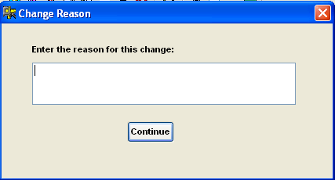
Enter a reason for the changes or addition. I.E. New Item, changed min and max, etc.
The next tab is Vendor Maint, click on this tab.

Vendor Maint
The Vendor Maint panel is used to review, update and add vendor information.
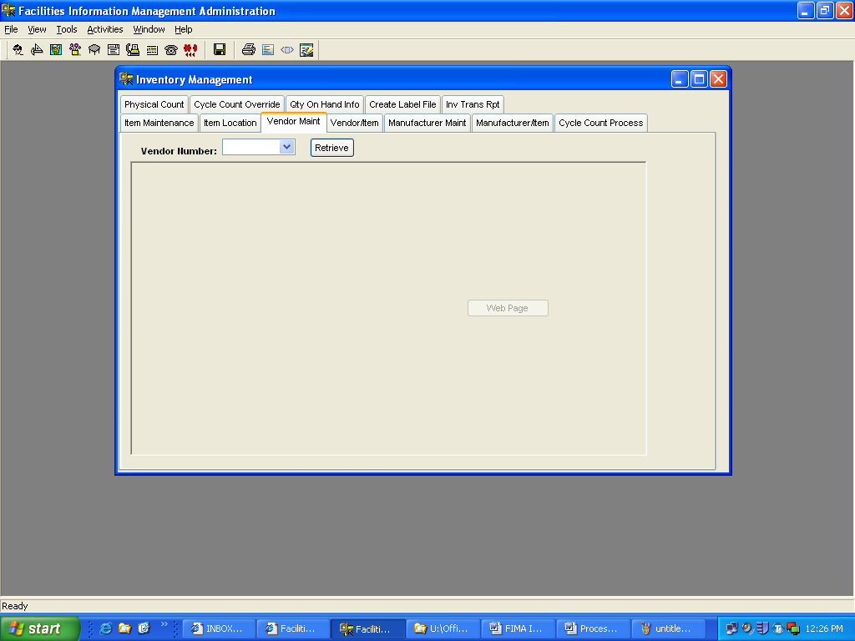
To review or change information for a vendor, click on the Drop Down Arrow. A list of vendors appears; select the vendor for review or change’s and then click the button. The below screens show the selected information.

Vendor selection.
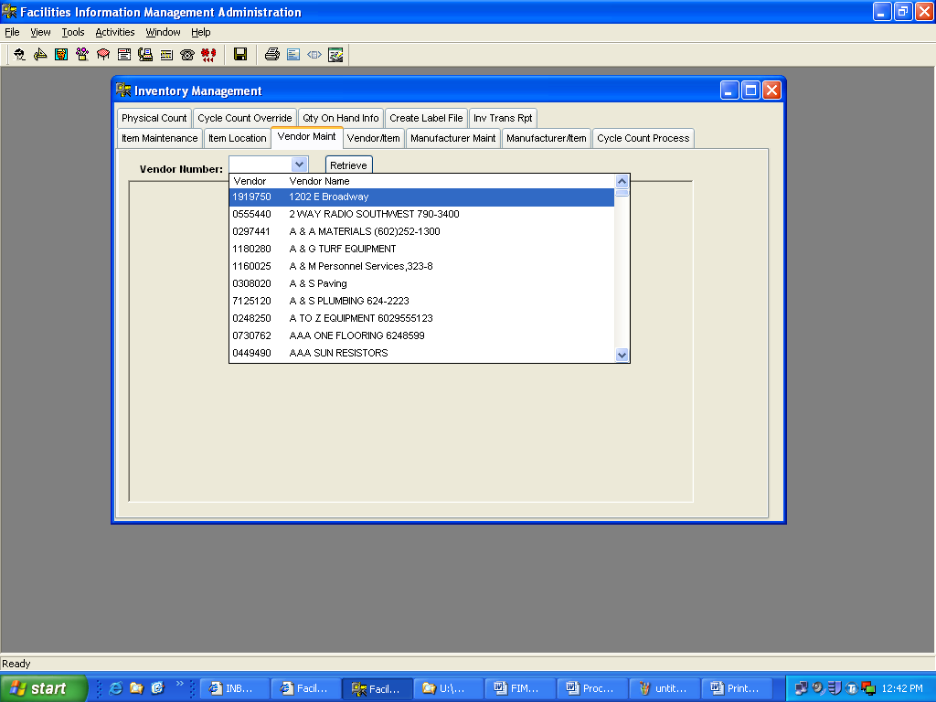
Vendor information.
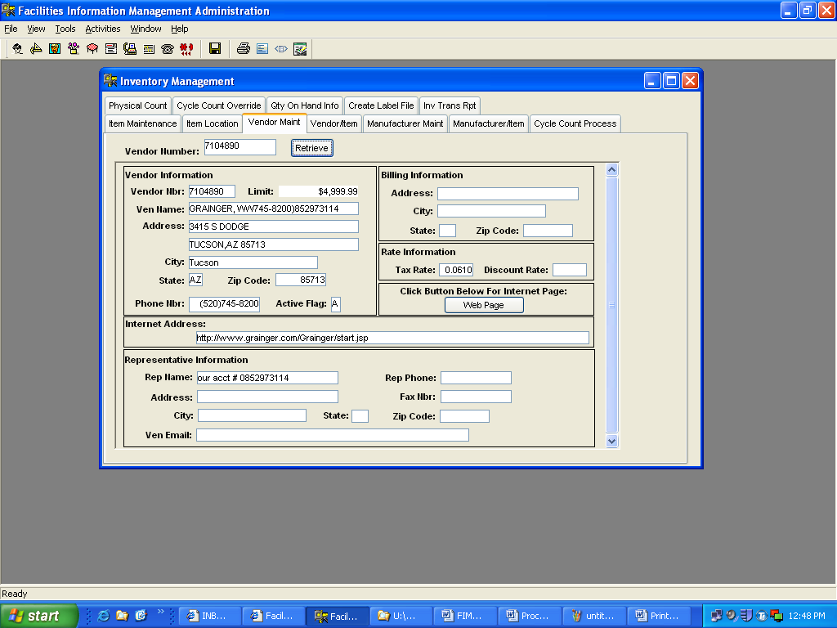
Now information can be viewed or changed.

There are six (6) sections on this panel. The first section is required information for each vendor. This section is Vendor Information and contains nine (9) blocks of information.
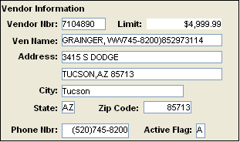
Vendor Nbr: Enter the Company’s phone number for new vendors.
Limit: This is the dollar amount that this vendor can charge per day.
Ven Name: Self Explanatory
Address: Enter the street address in the top block. Per the USPS, do no use punctuation marks in the address field. Example: P.O. Box 87566 should be PO Box 87566. 3415 S. Dodge -Suite #101 should be 3415 S Dodge Suite #101. The PO Box should be entered on the first line and the street address on the second line. Leave the second line blank if there is no other information.
City: Self Explanatory
State: Self Explanatory
Zip Code: Self Explanatory
Phone Nbr: Self Explanatory, must contain the area code
Active Flag: “A” for active, “I” for inactive
The next section is Billing Information and contains four (4) blocks information.
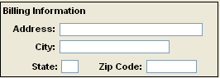
Only enter information here if the billing address is different from the mailing address.
Next is the Rate Information section and contains two (2) blocks of information.
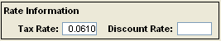
Tax Rate: Self Explanatory, if known.
Discount Rate: Self Explanatory, if known.
The Click Button Below For Internet Page section, there is no information entered here. This section is only available if a correct web page is entered into the next section.
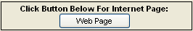
The next section is Internet Address and contains one (1) block of information. Enter the correct/complete internet web page in this block.
Next is the Representative Information section and contains eight (8) blocks of information.
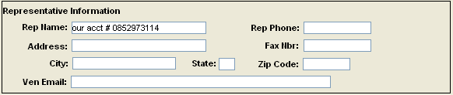
Rep Name: Representative’s name
Rep Phone: Representative’s phone number
Address: Representative’s street address
Fax Nbr: Representative’s fax number
City: Self Explanatory
State: Self Explanatory
Zip Code: Self Explanatory
Ven Email: Representative’s email address

To add a new vendor Right Click in any of the above mentioned sections and this screen appears. Follow the instructions above to enter the information for the new vendor.
